Akron RubberDucks Video Displays at 7 17 Credit Union Park
Main Video Board (right field)
Dimensions: 2016px W x 1224px H (Alternative Ratio - 16:9)
Still graphics: jpg or .png
Motion Graphics/Video: .mp4
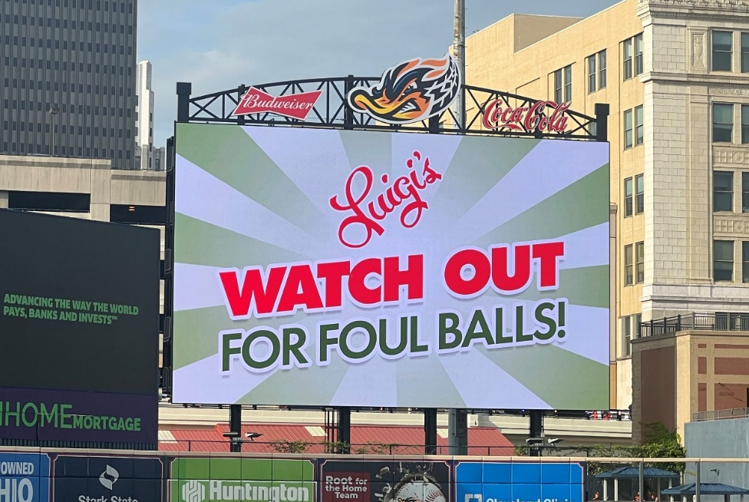

Ribbon Board (left field)
Dimensions: 1620px W x 360px H
Still graphics: jpg or .png
Motion Graphics/Video: .mp4
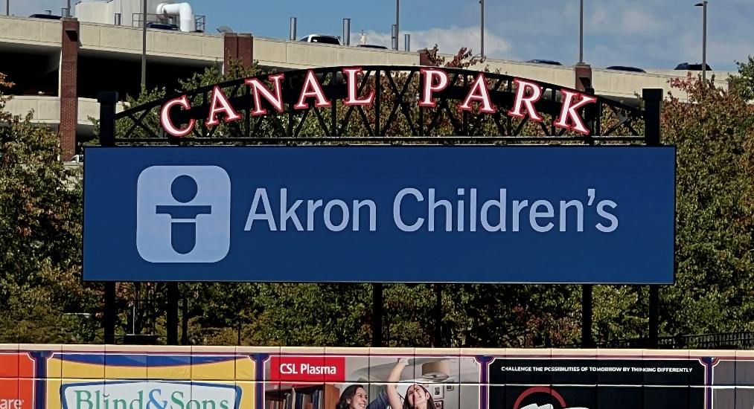

Suite Boards (behind 1st and 3rd base)
Dimensions: 1008px W x 108px H
Still graphics: jpg or .png
Motion Graphics/Video: .mp4
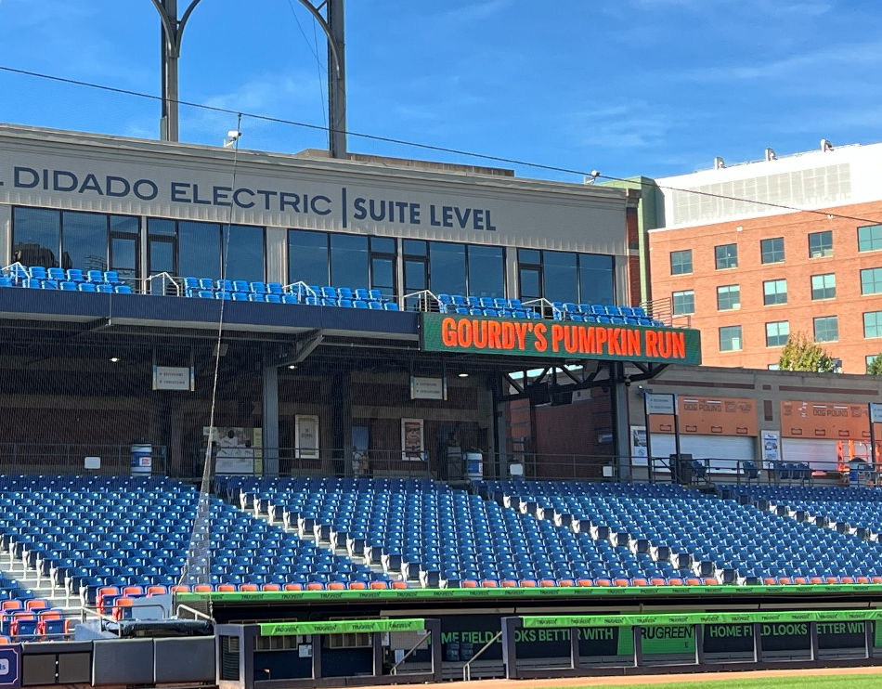

Concourse TVs (scattered throughout concourse)
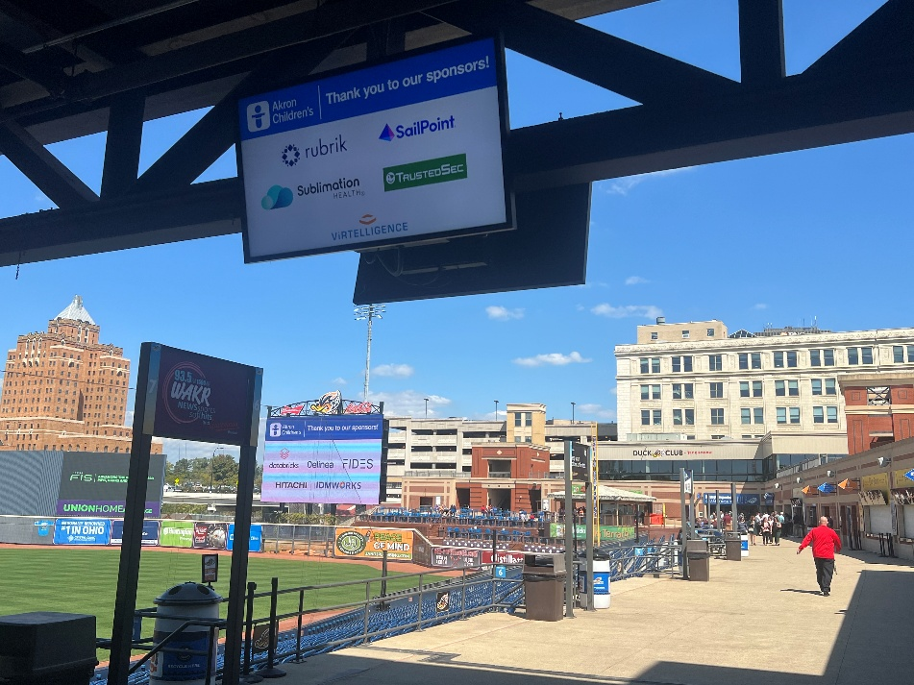
Dimensions: Ratio – 16:9
Still graphics: jpg or .png
Motion Graphics/Video: .mp4

Main Street Board (outside of building – part of rotation)
Dimensions: 360px W x 216px H
Still graphics: jpg or .png
Motion Graphics/Video: .mp4
